**Institute of Engineering & Management**

**Department of Computer Science & Engineering**

**Software Tools Laboratory for 2nd year 4th semester 2018**

**Code: CS 492**

**Date:** 17/01/18

**WEEK-1**

**Assignment-1**

**Problem Statement:** In an organization the gross salary of an employee depends on his/her Basic salary and some other allowances like  
Dearness Allowance (DA), House Rent Allowance (HRA) and Traveling Allowance (TA). According to the organization’s policy -  
DA = 40% of Basic salary  
HRA = 20% of Basic salary  
TA = 10% of Basic salary and  
The gross salary is calculated as –  
Gross salary = Basic salary + DA + HRA + TA  
  
Design two forms: 1 with two textboxes for Name and Basic Salary and a button to pop up another form displaying Name, Basic Salary, DA, HRA, TA and Gross Salary

**Screen-Shot:   
Form-1:**  
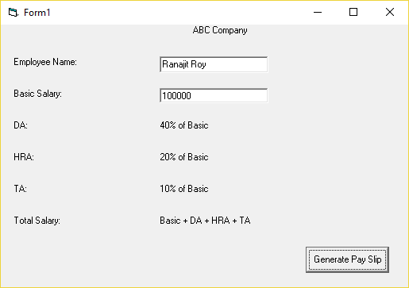 **Form-2:**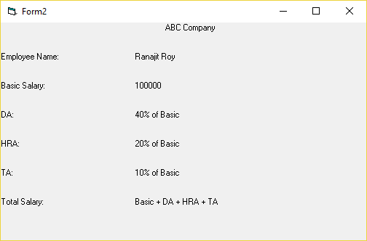

**Form Code:   
For Form-1:**

Private Sub Command1_Click()  
Form2.Label12.Caption = Text1.Text  
Form2.Label13.Caption = Text2.Text  
Form2.Show  
End Sub  
  
Private Sub Text2_Change()  
Form2.Label8.Caption = 0.4 * Val(Text2.Text)  
Form2.Label9.Caption = 0.2 * Val(Text2.Text)  
Form2.Label10.Caption = 0.1 * Val(Text2.Text)  
Form2.Label11.Caption = Val(Form2.Label8.Caption) + Val(Form2.Label9.Caption) + Val(Form2.Label10.Caption)  
End Sub

**Assignment-2**

**Problem Statement:** In an examination there are 5 subjects and the full marks in each subject is 100. The marks are summed up and a student  
gets a division as per the following rules:  
Percentage above or equal to 60 – 1st division.  
Percentage between 50 and 59 – 2nd division.  
Percentage between 40 and 49 – 3rd division.  
Percentage less than 40 – Fail.  
But, a student will be promoted if and only if he/she passes in at least three subjects.  
i) Design a form to give input the marks and student name  
ii) Generate a mark sheet for the student stating his/her division and whether he/she has been promoted or not

**Screen-Shot:   
Form-1:**

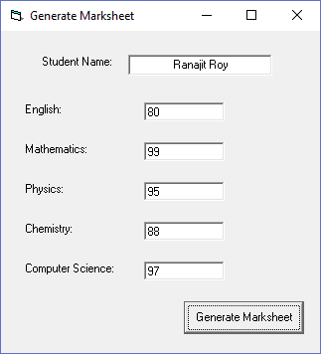

**Form-2:**

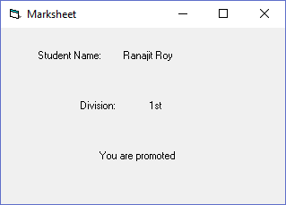

**Form Code:   
For Form-1:**

Private Sub Command1_Click()  
Form2.Label2.Caption = Text1.Text  
Form2.Label5.Caption = "You are promoted"  
Dim flag As Integer  
flag = 0  
If Val(Text2.Text) < 40 Then  
flag = flag + 1  
End If  
If Val(Text3.Text) < 40 Then  
flag = flag + 1  
End If  
If Val(Text4.Text) < 40 Then  
flag = flag + 1  
End If  
If Val(Text5.Text) < 40 Then  
flag = flag + 1  
End If  
Dim total As Integer  
total = Val(Text2.Text) + Val(Text3.Text) + Val(Text4.Text) + Val(Text5.Text) + Val(Text6.Text)  
If total >= 300 Then  
Form2.Label4.Caption = "1st"  
ElseIf total >= 250 Then Form2.Label4.Caption = "2nd"  
ElseIf total >= 200 Then Form2.Label4.Caption = "3rd"  
Else: Form2.Label4.Caption = "FAIL"  
Form2.Label5.Caption = "You are not promoted"  
End If  
If flag > 2 Then  
Form2.Label4.Caption = "FAIL"  
Form2.Label5.Caption = "You are not promoted"  
End If  
Form2.Show  
End Sub

**Assignment-3**

**Problem Statement:** A certain grade of steel is graded according to the following conditions:  
Hardness must be greater than 50  
Carbon content must be less than 0.7  
Tensile strength must be greater than 5600.  
The grades are as follows:  
Grade is 10 if all three conditions are met.  
Grade is 9 if conditions (i) and (ii) are met.  
Grade is 8 if conditions (ii) and (iii) are met.  
Grade is 7 if conditions (i) and (iii) are met.  
Grade is 6 if one condition is met.  
Grade is 5 if none of the conditions are met.  
Design a proper User Interface (UI), which will require the user to give values of hardness, carbon content and tensile strength of the steel  
under consideration and output the grade of the steel.

**Screen-Shot:   
Form-1:**

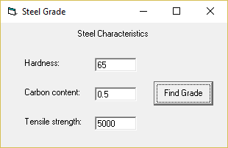

**Message Box:**

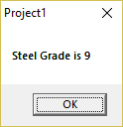

**Form Code:   
For Form-1:**

Private Sub Command1_Click()  
If Hard.Text = "" Or Carbon.Text = "" Or Tens.Text = "" Then  
MsgBox ("Invalid Input")  
ElseIf Val(Hard.Text) > 50 And Val(Carbon.Text) < 0.7 And Val(Tens.Text) > 5600 Then  
MsgBox ("Steel Grade is 10")  
ElseIf Val(Hard.Text) > 50 And Val(Carbon.Text) < 0.7 Then  
MsgBox ("Steel Grade is 9")  
ElseIf Val(Carbon.Text) < 0.7 And Val(Tens.Text) > 5600 Then  
MsgBox ("Steel Grade is 8")  
ElseIf Val(Hard.Text) > 50 And Val(Tens.Text) > 5600 Then  
MsgBox ("Steel Grade is 7")  
ElseIf Val(Hard.Text) > 50 Or Val(Carbon.Text) < 0.7 Or Val(Tens.Text) > 5600 Then  
MsgBox ("Steel Grade is 6")  
Else  
MsgBox ("Steel Grade is 5")  
End If  
End Sub